Curriculum Vitae
Linkedin Profile (contains a lot more details) :  http://www.linkedin.com/pub/david-gagnon/28/a1/466  E-mail :  toogreen@gmail.com | David Gagnon  8340, ave de Chateaubriand  H2P 2A1, Montréal  Home : (438) 383-3600  Mobile : (438) 985-5500
Profile
Honest and reliable, autodidact, hungry for learning and able to adapt to change. Passionate about IT technologies means always up-to-date with newest trends. Open Source technologies expert. Great knowledge of all IT technologies and systems, including Mac OS X, Windows PC, UNIX/Linux, Android & iOS. I am looking forward to working in a dynamic high-tech environment which will make best use of my management and IT skills. I am a long time Linux user, since 1997.
Experience
Softvoyage – November 2012 to March 2014
Web Designer and CSS/jQuery/HTML5 Developer. Working on general graphic design as well as HTML5 development and UI design, with a special focus on mobile devices and responsive design. More recently started developing in-house web applications using PHP and MySQL/MariaDB.
Some notable projects related to above position :
- Main Softvoyage Website (www.softvoyage.com)
Based on a provided design, I have mostly built this Wordpress website's content and functionalities
- HTML5 Holidays Greetings card (holidays.softvoyage.com)
Greetings card built entirely in HTML5/CSS3 and jQuery.
- AvenirMD (www.avenirmd.com)
Side project I worked on, built the entire Wordpress website based on a template that I heavily modified using PHP and jQuery.
Shanghai United International School — 2004-2012
Cross-campus coordinator for a series of primary schools in Shanghai (Xiehe Education Group). I acted as an advisor, system administrator, facilitator and teacher. My tasks included managing the IT infrastructures across campuses and administrating the school’s web servers, databases, e-mail, FTP, Administration desk, etc. I have also deployed a Learning Management System (Moodle) and developed several web apps and databases for administrative functions (PHP+MySQL). On top of that, I was also providing technical support and training to teachers, as well as teaching ICT to primary and secondary school students. I followed the IB curriculum program as well as IPC and the English National Curriculum. You can consult some of my IB workshops attendance certificates by following this link.
Some notable projects related to above position :
- Main Xiehe Education Organisation website portal
I have set up, designed, and administered this website based on Drupal until June 2012. It's now unfortunately out of date and lacks the quality I would normally require, but it used to actually look good when I was still in charge of it!
- Moodle installation at Shanghai United International School
I have set up the Linux server (Debian), then set up and administered this Moodle website until June 2012. What it looks like now may not reflect my work anymore but I have originally built, set up, administered and maintained it in the past.
- Students Database and Reporting System
I have helped create and maintain an online, PHP-based administrative database system for storing students information and monitoring other school management matters such as taking attendance, comments, transportation info, reports, etc. I have built the entire reports system from scratch using PHP, HTML and MySQL.
- Portable Netbooks Trolley
Designed a trolley system for Netbooks that is now in use in Shangyin Campus. Click on title above to see the actual plans.
- Set up and maintenance of LAMP servers (Debian), Web services (Apache), Email (postfix+courier), file servers
I have set up all the original Linux servers in the school, which ran websites and all the web apps, as well as the original main email system for all the schools based on Postfix and Courier.
- Set up of Access-IT Library Software Platform
I've performed the installation and set up of the library systems "Access-IT" on the Linux servers as well as the database systems required
Freelancing — 2003-2004
Web and Print design, as well as teaching English for various schools around Shanghai.
Projects : wonderful-earth.com, photojournaliste.ca, iqi.com, xlnt.com, logos corpos, etc.
Propage Technologies Interactives — 1999-2002
Full-time web designer, programmer and webmaster. Used technologies such as HTML, PHP, ASP, as well as programs like Dreamweaver, Flash, and much more. Both designed and programmed websites. Worked with Windows and Linux workstations.
Projects : vallee.ca, novabus.com, garaga.com, ver-mac.com, ateq.qc.ca, camps-odyssee.com, daaquam.com, sportsmontreal.com, le1000.com, and much more!
Freelancing — 1997-1999
Freelancing for various web design projects as well as printed graphics and documents.

Education
Rochebelle Professional Formation Center, Québec City — DEP, 1997-1999
DEP in Graphic Design. Studied and practiced pre-print design work as well as web design, including internship experience for a web design company (SillyWeb)
Skills & Qualifications
System Administrator | Linux servers administration. Amazon EC2, LAMP setup, Moodle, Postfix, Courier, BIND, etc.
Teacher | I have been teaching for over 8 years in Shanghai. Taught English as well as ICT to children aged from 5 to 14 years old. Also gave several trainings to adults on IT systems such as LibreOffice and Moodle.
Coordinator | Been in charge of coordinating ICT between 5 different campuses, as well as providing IT trainings to professional teaching staff from around the globe.
Developer | I have built websites and on-line apps in HTML5/CSS3/PHP/MySQL. I can do a little bit of backend but I mostly excel at front-end.
IB Facilitator | ICT IB PYP Facilitator, attended several ICT & PYP workshops and Job-A-Likes. Expert Moodle trainer and administrator.
Graphic Designer | I have designed various website designs, logos as well as printed material.
Lecturer | Gave several talks and workshops on the use of Open Source software in Education.
Visionary | Tend to be gifted at choosing the right sustainable technologies for the long term, can usually predictupcoming trends, and therefore chooses the right technologies that will last.
Blogger | Currently writing weekly articles for Nelson Dumais, Le Magazine (http://www.nelsondumais.com)
Bilingual | Native French speaker, fluent in English, also knows some Mandarin Chinese.

Portfolio (overview) :

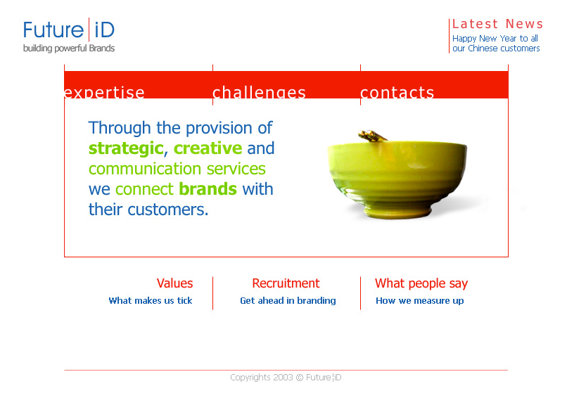
Corporate Logos :




Websites :
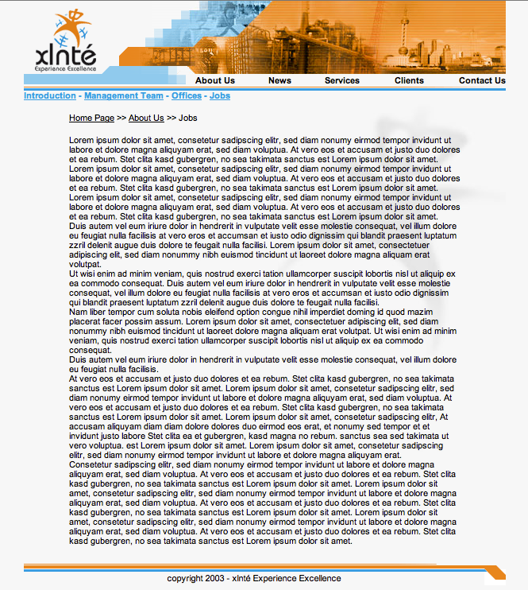


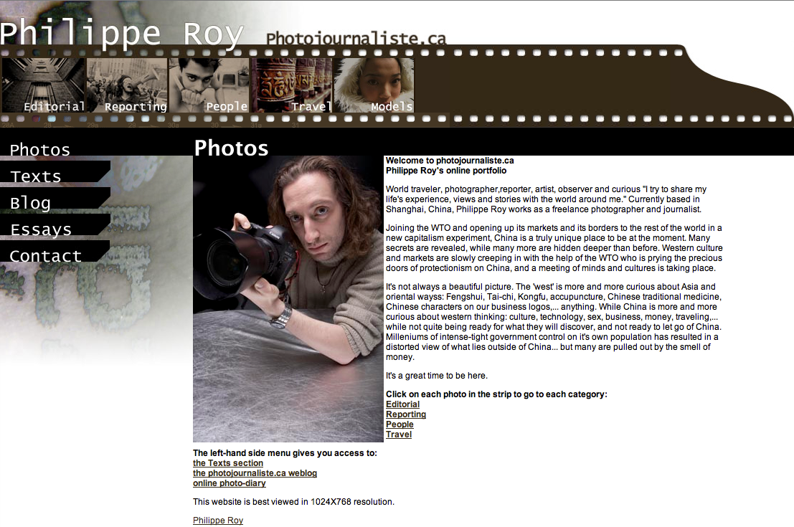



Projects portfolio
A few projects that I worked on, more in details...
www.softvoyage.com
Our company needed a major revamp for the main web portal.  I've done most of work behind taking a design idea and turning it into a full blown Wordpress template.  Used HTML5, CSS3, PHP and jQuery technologies to make everything work as it should.  The website presenting a couple of challenges later on a well, for instance adapting all the PHP templates  from being simply bilingual (French + English) to a tri-lingual version (added Spanish recently). |  |  |  | 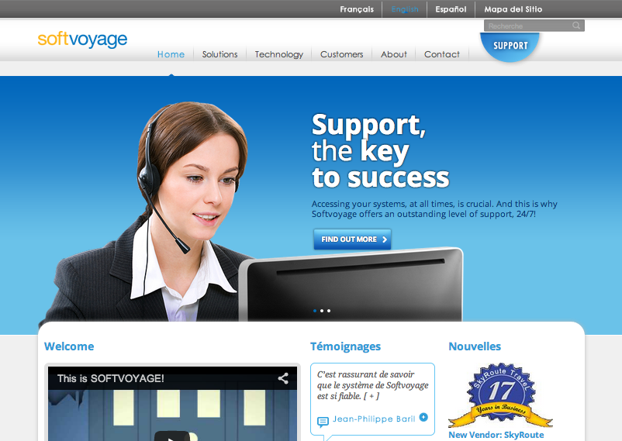
www.avenirmd.com
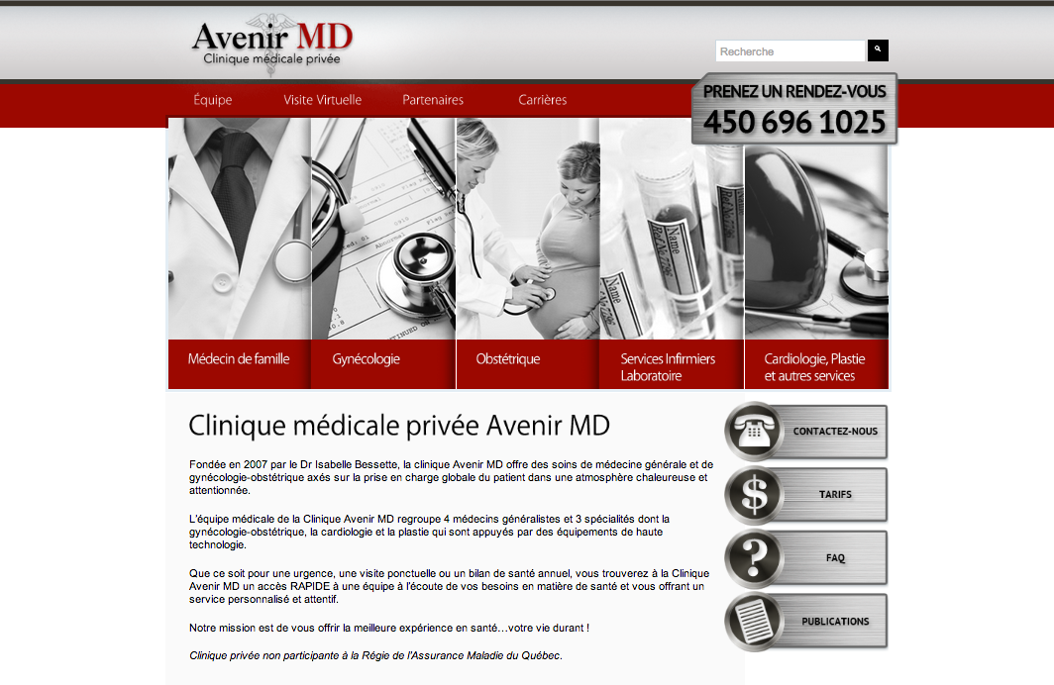 | This private clinic needed a brand new, better looking Wordpress-based website.  Starting from an exisiting template, I have modified its code heavily using CSS3 and jQuery to add some new features, such as making the main pictures becoming in color when rolling the mouse over them, as well as adding sub-menus and right sidebar, etc.  It was the first time I used jQuery extensively and some interesting CSS3 newer features.
www.suis.com.cn
Shanghai's « Xiehe Education Group » manages several schools around Shanghai.  I am the one who created their portal, from the installation and configuration of the Linux server, followed by the installation and set up of the Drupal CMS, as well as the graphic signature which I designed by modifying an existing Drupal template. I also added a bit of PHP code for extras.  It's also myself who has put in place their email server as well as the Learning Management System based on the Moodle Open Source software. |  |  |  |  | 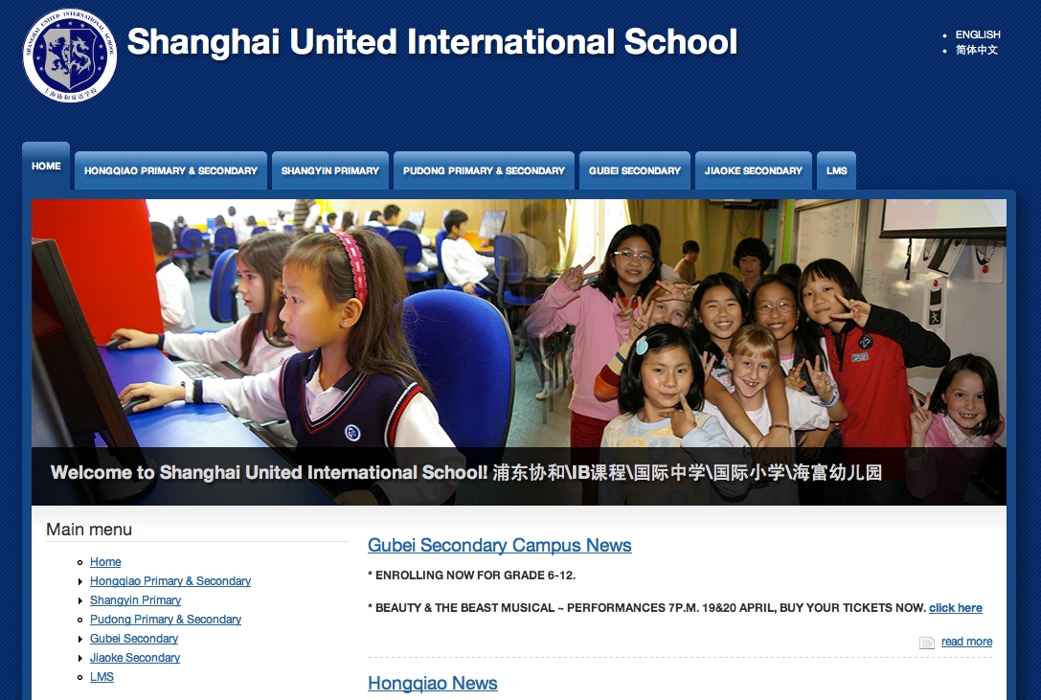
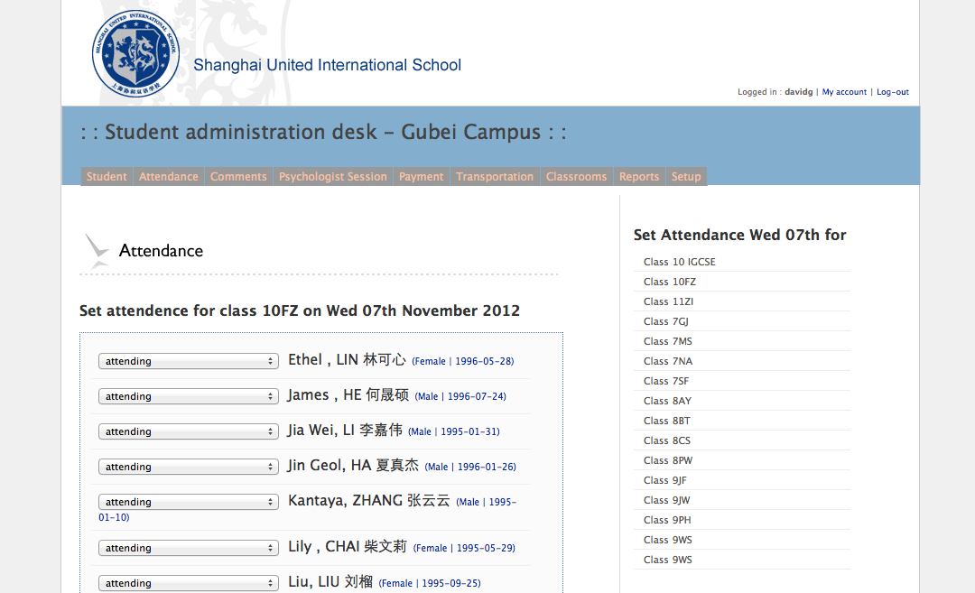
Students Administration Desk
I have extended this in-house developed management system, based on PHP and MySQL by building on top of its original source code. This system is still being used to manage information about students, take daily attendance, set up buses, write comments, etc. My contribution consists in two modules that I created from scratch and integrated into the existing system:
- On-line reports web interface which allows teachers to input students' grades, as well as store, view and print reports directly on-line.
- A web interface allowing teachers to input their lesson plans directly on-line and from home, as well as sharing them with other teachers.
photojournaliste.ca
A website I've built in 2003 for a photographer friend which was also based in Shanghai. He needed a website to promote himself and his portfolio.
This was the very first website in which I used the PHP and MySQL technologies.
Again I've done everything, from scanning the original pictures from film, to graphic design then HTML slicing and PHP, MySQL, HTML, CSS and JavaScript programming.
Thanks to PHP/MySQL, this website could be easily updated by his owner, for example adding text or photos, without having to do any programming or requiring my assistance.
wonderful-earth.com
This Shanghai-established textile design and production company needed a simple and stylish website to sell themselves on the web and make their entire products catalog on-line.
I have therefore done everything, from taking their products photos myself, the visual design of the website, to finally program the entire site using HTML, CSS et JavaScript technologies.
It was the first time I made use of « layers » and Javascript to control some animations.

Reference Mr David Gagnon.

I have known Mr Gagnon for 5.5 years in his capacity as ICT teacher and Advisor for the ICT area in Xiehe.Xiehe is the largest provider of Private education in China mainly located at present in Shanghai.The organization is concerned with some 40 schools/Institutions but it is with the International school division that Mr Gagnon has mainly been involved.
I have always been impressed with the work ethic of Mr Gagnon and his capacity to quickly determine what is the most relevant practice to be pursued to ensure the organization can identify its goals and needs.He then has established quickly the procedures we should follow to achieve these objectives.
Apart from his excellent teaching I have always been impressed with Mr Gagnons ability to visit all Xiehe campus’s to discuss ICT needs and help campus based personel at teaching and administrative levels achieve their targets.
He has also on a regular basis briefed Principals as to what they should do in terms of policy and practice and has fully developed the organizational structure of Xiehe ICT facilities to meet the needs of the current century.
He is a humble but very able ICT theoretician and practitioner who I fully recommend to you without reservation as a teacher /adviser and one who we would wish to re-employ should the opportunity offer itself.
Should any further information be required please do not hesitate to request it.I recommend him to you as an excellent candidate for any post or area of Study for which he might apply

Yours sincerely

Dr Roger W R Morgan.
Principal SUIS.Pu Dong
Chief Inspector Xiehe Education.
29th June 2012.

MEMO TO: Whom it may concern

FROM: Martin Donnellan

DATE: 31 August 2012

RE: David Gagnon

RE: DAVID GAGNON

I worked with David Gagnon from August 2010 when I came to Shanghai as Principal of this school. David worked as an ICT teacher across the school and as the key professional in charge of all of our IT systems and services.

Most striking about David is his knowledge of his subject area and the skills inherent therein. As well as a (reduced) teaching load he worked assiduously to create and maintain our website and those of five sister schools in our organization across the city. This also involved training a large number of personnel which he did with a great deal of skill and no little patience. He maintained our email system and administered our ‘Teacher Shared’ electronic resource archive. His commitment to the highest standards of professional practice was admirable; systems were invariably reliable and backed up as a matter of course on his watch.

David is clearly self-motivated and multi-skilled. He keeps right up to date with technological developments and is ever ready and eager to discuss the relevance and application of such technologies to the workplace. He is a very fine example of a lifelong learner. He also deals very well with people and the equanimity which he shows in a trouble – shooting ICT environment is most impressive.

David was one of the longest standing members of the school staff after nine years here. We were very sorry to see him go but wished him and his wife every success in their new life in Canada.

I have no hesitation in recommending him to a prospective employer. They would be receiving a mature, reflective, skilled and dedicated professional who would contribute much added value to their organization or enterprise.

I shall be happy to offer any further clarification you might require.

Martin F. Donnellan
Principal, Shanghai United International School

